Белорусский государственный технологический университет

Факультет информационных технологий

Кафедра программной инженерии

 Лабораторная работа 5

По дисциплине «Основы программной инженерии»

На тему «Структурное программирование»

Выполнил:

Студент 1 курса 6 группы

Кучерук Николай Петрович

Преподаватель: доц. Наркевич А.С.

2023, Минск

**Задание**

1.

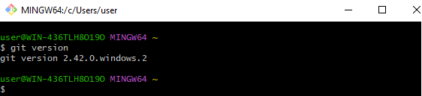

2.

GNU bash, version 5.2.15(1)-release (x86_64-pc-msys)

These shell commands are defined internally. Type `help' to see this list.

Type `help name' to find out more about the function `name'.

Use `info bash' to find out more about the shell in general.

Use `man -k' or `info' to find out more about commands not in this list.

A star (*) next to a name means that the command is disabled.

job_spec [&] history [-c] [-d offset] [n] or hist>

(( expression )) if COMMANDS; then COMMANDS; [ elif C>

. filename [arguments] jobs [-lnprs] [jobspec ...] or jobs >

: kill [-s sigspec | -n signum | -sigs>

[ arg... ] let arg [arg ...]

[[ expression ]] local [option] name[=value] ...

alias [-p] [name[=value] ... ] logout [n]

bg [job_spec ...] mapfile [-d delim] [-n count] [-O or>

bind [-lpsvPSVX] [-m keymap] [-f file> popd [-n] [+N | -N]

break [n] printf [-v var] format [arguments]

builtin [shell-builtin [arg ...]] pushd [-n] [+N | -N | dir]

caller [expr] pwd [-LPW]

case WORD in [PATTERN [| PATTERN]...)> read [-ers] [-a array] [-d delim] [->

cd [-L|[-P [-e]] [-@]] [dir] readarray [-d delim] [-n count] [-O >

command [-pVv] command [arg ...] readonly [-aAf] [name[=value] ...] o>

compgen [-abcdefgjksuv] [-o option] [> return [n]

complete [-abcdefgjksuv] [-pr] [-DEI]> select NAME [in WORDS ... ;] do COMM>

compopt [-o|+o option] [-DEI] [name .> set [-abefhkmnptuvxBCEHPT] [-o optio>

continue [n] shift [n]

coproc [NAME] command [redirections] shopt [-pqsu] [-o] [optname ...]

declare [-aAfFgiIlnrtux] [name[=value> source filename [arguments]

dirs [-clpv] [+N] [-N] suspend [-f]

disown [-h] [-ar] [jobspec ... | pid > test [expr]

echo [-neE] [arg ...] time [-p] pipeline

enable [-a] [-dnps] [-f filename] [na> times

eval [arg ...] trap [-lp] [[arg] signal_spec ...]

exec [-cl] [-a name] [command [argume> true

exit [n] type [-afptP] name [name ...]

export [-fn] [name[=value] ...] or ex> typeset [-aAfFgiIlnrtux] name[=value>

false ulimit [-SHabcdefiklmnpqrstuvxPRT] [>

fc [-e ename] [-lnr] [first] [last] o> umask [-p] [-S] [mode]

fg [job_spec] unalias [-a] name [name ...]

for NAME [in WORDS ... ] ; do COMMAND> unset [-f] [-v] [-n] [name ...]

for (( exp1; exp2; exp3 )); do COMMAN> until COMMANDS; do COMMANDS-2; done

function name { COMMANDS ; } or name > variables - Names and meanings of so>

getopts optstring name [arg ...] wait [-fn] [-p var] [id ...]

hash [-lr] [-p pathname] [-dt] [name > while COMMANDS; do COMMANDS-2; done

help [-dms] [pattern ...] { COMMANDS ; }

3.

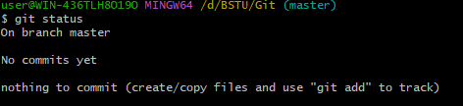

4.

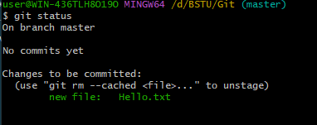

5.

